**ARYAMAN MISHRA**

**19BCE1027**

**AIM: Design and simulation of PCB circuit in EasyEDA**

**TOOLS USED:EasyEDA**

**IMPLEMENTATION:**

**CIRCUIT:**

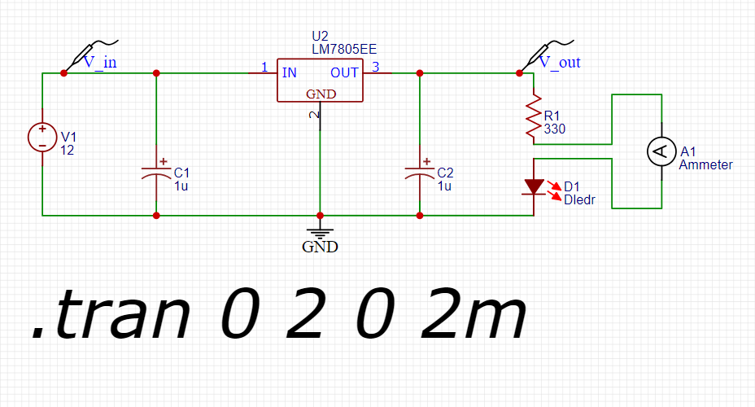

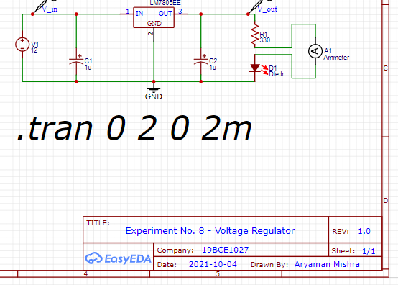

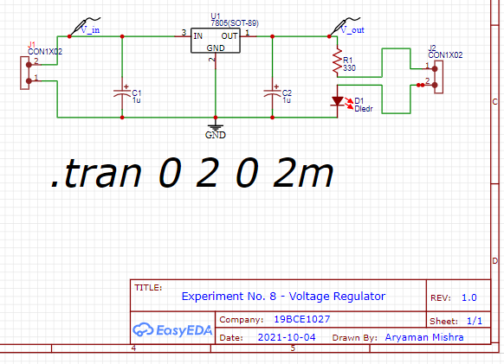

**GRAPHS:**

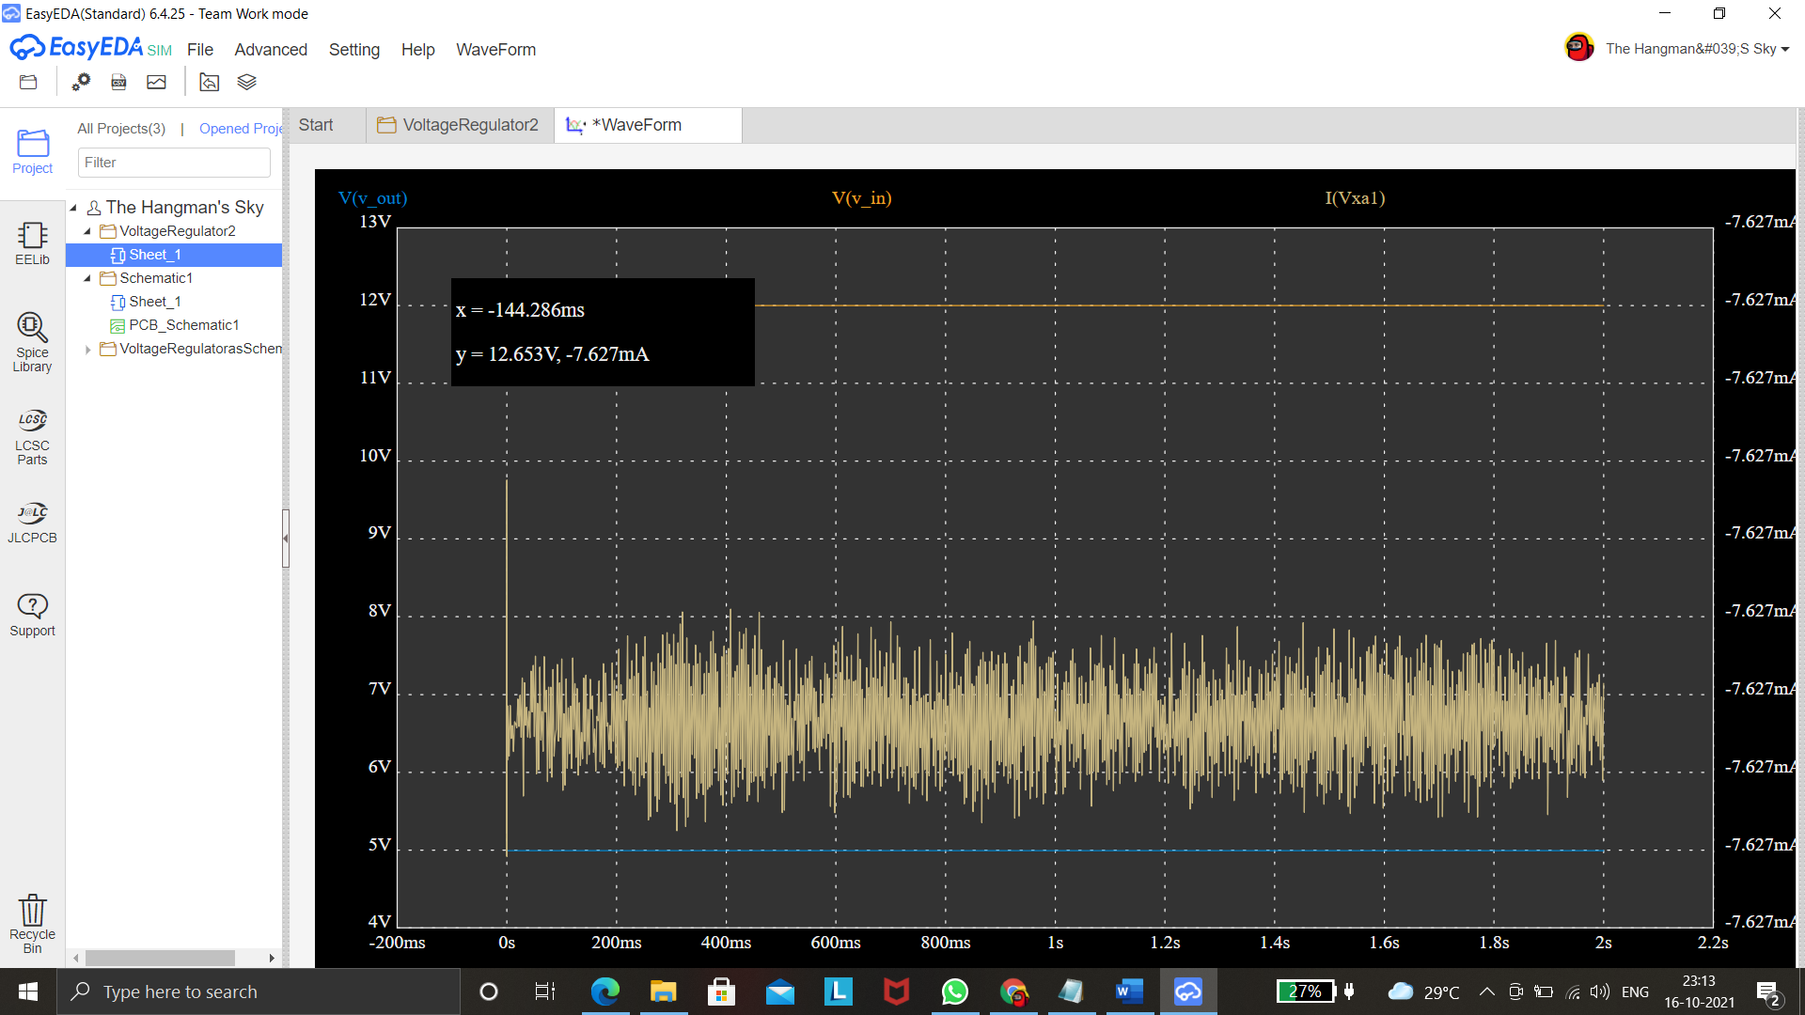



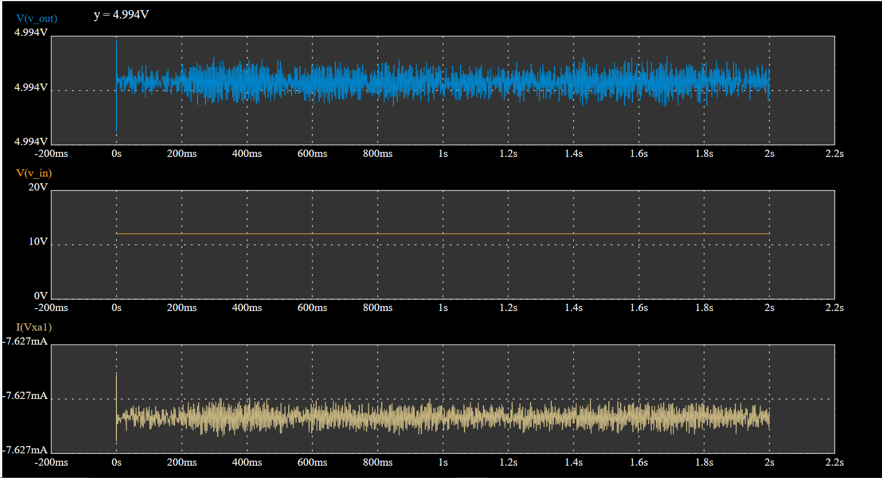



**PCB DIAGRAM:**

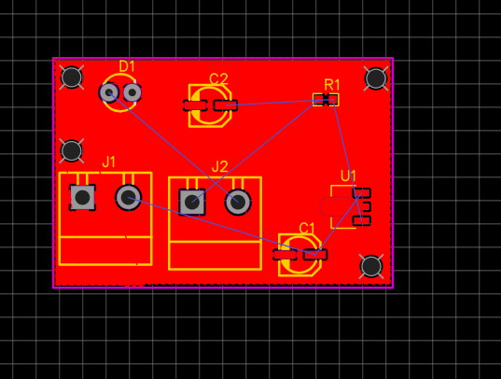



Routing of every PCB Diagram for every member will be different.

**Conclusion:**

From The output waveform of voltage regulator we can observe that when the input voltage is given as 12 v gives an output voltage 4.994 V which is approximately 5 V it means whatever may the current value the output will remain 5 V throughout.

In the PCB circuit of a voltage regulator J1 and J2 are the connectors, C1and C2 are the capacitors, R1 is the resistor, D1 is the led diode and U1 is the 7805-voltage regulator and the red color shows the cooper area usually referred as GND.

Thus, we successfully designed a voltage regulator and PCB circuit using EasyEDA tool and analyzed its output waveform.

Voltage Regulator has been successfully implemented in EasyEDA.